Reviewing SLA Tiers concepts on API Manager
A Service Level Access (SLA) tier is a category of user access that you define for an API. The tier definition combined with an SLA-based policy determines whether access to the API at a certain level requires your approval. The tier definition also can limit the number of requests an application can make to the API. To enforce SLA tiers, you need to apply a rate-limiting or throttling policy that is SLA-based.

To define SLA tiers for an API version or to manage applications that request access to specific tiers, you need to set the API URL.

You can monitor SLA performance to ensure that your APIs are performing in line with the SLA tier approved for an API.

Defining a Tier
When you define a tier, you name the tier and define limits, such as the number of requests calling apps can make. You also indicate whether application access requests at this tier level should be automatically approved or require manual approval.

On SLA Tiers on the API version details page, a summary of the SLA tier definition appears showing how many applications are registered on that tier and other information, tier name, limits, status, and required approval type.

You can edit and delete the tier using the provided controls.

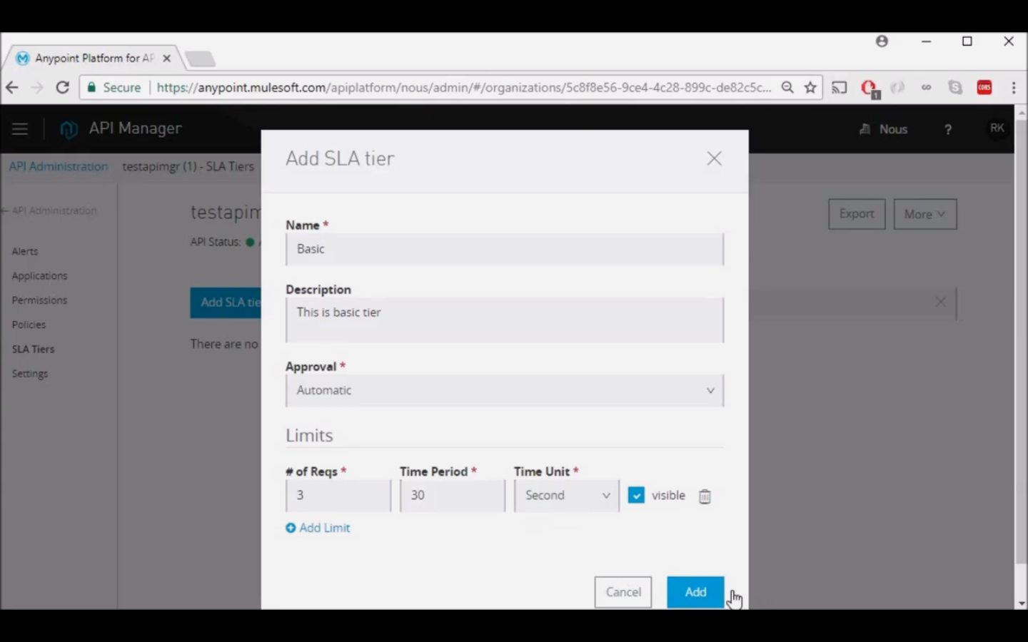

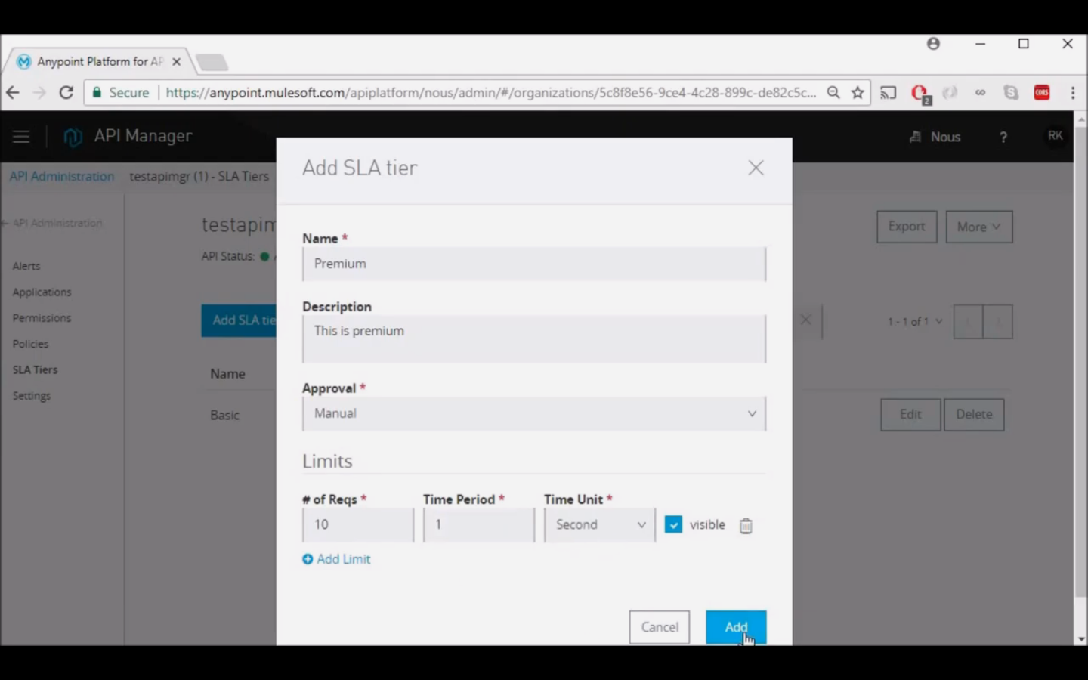
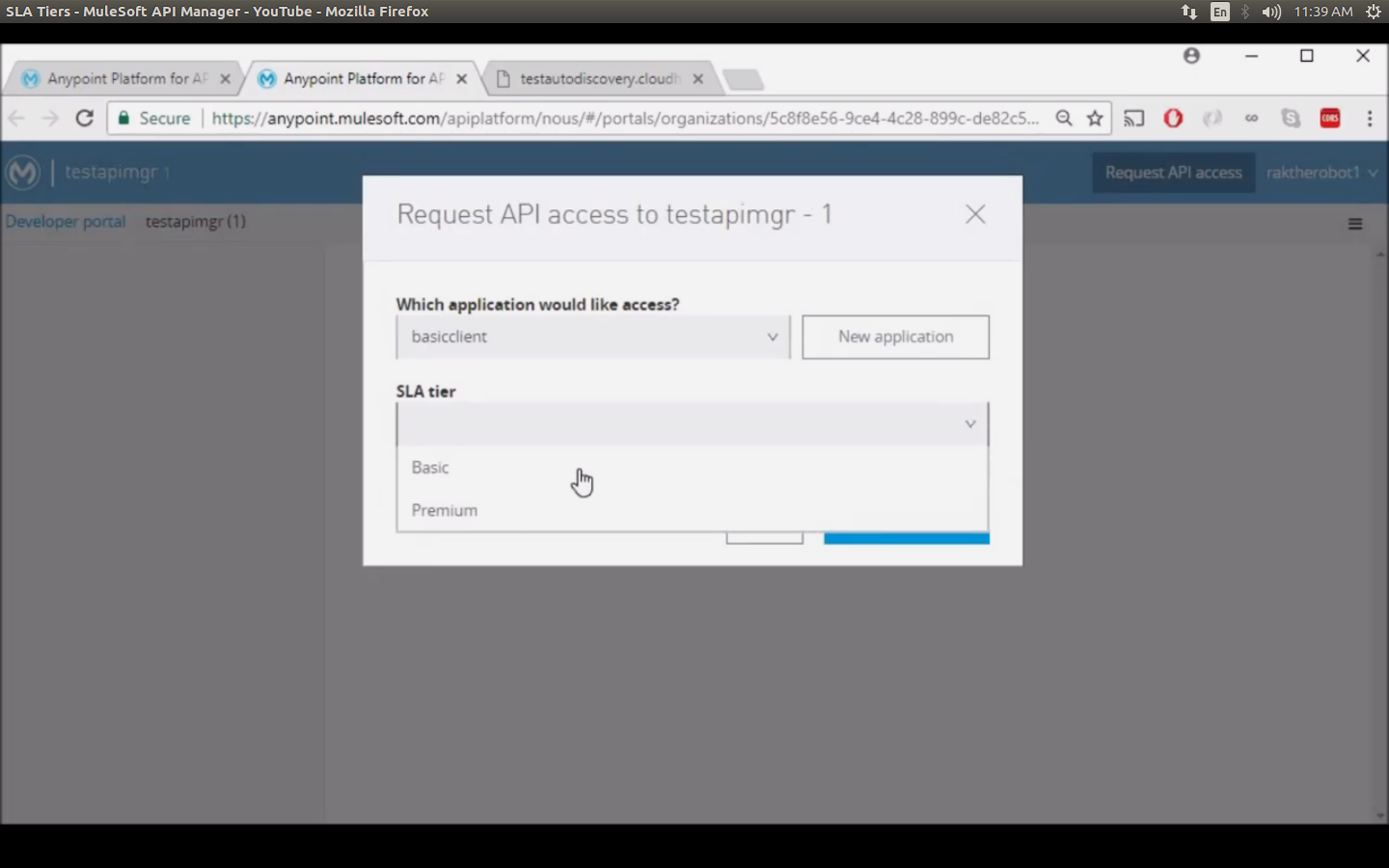

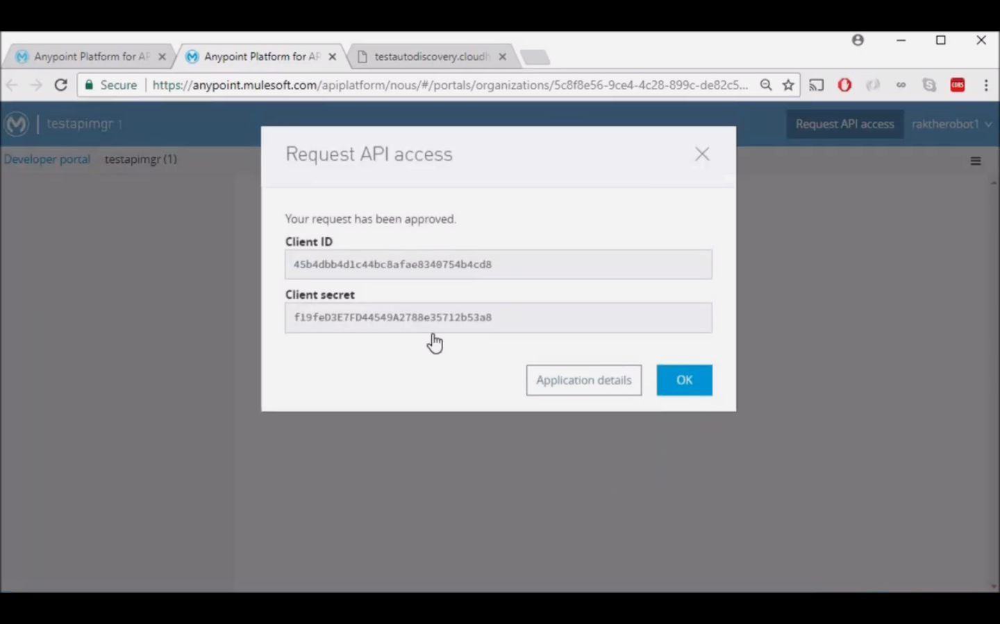

Layered SLAs

API Manager supports multiple SLA limits are supported.

You can set multiple throughput limits for a single SLA tier. A single SLA tier named gold can limit requests to 100 per second as well as limiting requests to 10,000 per day. This technique ensures that applications registered on a gold tier don’t exceed a bursting limit of 100 requests per second. Applications do not overwhelm the API, and registered applications get the expected 10,000 request per day. Setting the Visible flag on an SLA hides the first limit from application developers at registration time. If you define only one limit, you cannot hide it.

Enforcing a Tier
To enforce SLA tiers, you need to apply a rate-limiting or throttling policy that is SLA-based. These policies require all applications that consume the API to register for access to a specific tier, then pass their client credentials in calls to the API, so that Anypoint Platform can identify them, associate them with their contracted tier, and enforce the throughput limitation.

Editing a Tier
If you edit a tier that already has applications approved to use that tier, those applications are immediately held to the terms of the edited tier. Thus, if you change the throughput values without warning, you might inconvenience API users.

If you originally set the tier to require manual approval, and change it to allow automatic approvals, API Manager grants any pending approval requests.

Managing Applications
After you define an SLA for an API, you can approve or revoke access requests from app developers through the Exchange Portal. This action binds consumption of the application to an SLA. If a developer requests access to your API at a higher SLA tier than you want to approve, you can override the request by applying another SLA tier.

If you set the tiers for manual approval, email notifications are sent to you when developers request access for their applications. You can review the applications on the API version details page and approve, reject, or revoke requests. If a developer asks to change tiers, you can also review the change request and approve the application for the new tier or reject the change request.

Deprecating and Deleting Tiers
After you assign applications to SLA tiers, you have the option to deprecate a tier to prevent developers from signing up new applications up for that tier. You cannot delete an SLA tier that has applications assigned to it.
To deprecate and delete a tier, first create a new tier and notify application owners of the new tier name that you create. Next, revoke application access to the existing, deprecated tier. Ask the application owners to re-request access to the API using the new tier. Finally, after all application owners sign up for a new tier and you approve their move to the new tier, you can delete the deprecated tier.

Removing SLA Tiers on API Manager:
1. Create a new SLA tier:
- In API Manager, in API Administration, click an API instance.
- On the API dashboard, select SLA Tiers.
- Set up and add the new SLA Tier.
2. Notify application owners of the new tier name and ask them to re-request access to the API using the new tier.
3. After all application owners sign up for a new tier and you approve their move to the new tier, delete the old tier:
- On the API dashbaord, select SLA Tiers.
- Click Delete.

Accessing the Developer Portal

API portals listed on an organization’s developer portal that are public, or to which you have been granted Portals Viewer access, are visible to you. From the public Anypoint Platform Developer portal, you can access Anypoint Platform APIs to automate Anypoint Platform activities.

In API Manager, from the API Administration page, use the hamburger menu on the right. Alternatively, use the following procedure.

To access the Anypoint Platform Developer Portal:

The Anypoint Platform developer portal is a public portal that you can find by searching on the internet or by clicking the link at the bottom of this page.

To access your organization’s developer portal, use one of the following methods:

- Go to Access Management > Organization, and click the name of your organization. Organization Info appears, showing the Domain Name.
- Go to your organization’s developer portal using a URL in the following format, substituting domain-name for your organization’s domain name:

Reviewing API Proxy Benefits and Impacts

The tables below describe the main benefits and impacts of implementing the different types of API Proxies.

Benefits:
Benefit | WSDL | RAML/OAS | HTTP | HTTPS
Tracks proxy in API Manager and generates API analytics. Requires Autodiscovery. | yes | yes | yes | yes
Applies policies for API governance. | yes | yes | yes | yes
Sends errors related to MuleSoft-provided policies as soap:fault messages | yes | no | no | no
Includes API Console for simulating API requests.  By default, you can open API Console using a URL in the format: <host_of_your_proxy>:<port_of_your_proxy>/console | no | yes | no | no

Impacts:
These are the impacts on your requests going through your API proxies.
Impact | WSDL | RAML/OAS | HTTP | HTTPS
Includes X-Forwarded-For headers. | yes | yes | yes | yes
Sends received headers to implementation API except Mule-included ones.  Mule-included headers are, for example, X-MULE-SESSION, and X-MULE-ENCODING, among others. | yes | yes | yes | yes
Validates headers, body, URI, query, and form parameters API against RAML 0.8/1.0. | no | yes | no | no
Provides default parameter values if specified in RAML but absent from request. | no | yes | no | no
Handles a secure connection using the keystore and truststore provided in the TLS configuration for server authentication. | no | no | no | yes

Handling API Proxy status codes:

In Mule 4, WSDL, RAML, HTTP, and HTTPS proxies handle errors and requests as described in the following tables. Mule 4 returns different error codes, depending on the proxy type, or no error code in response to problematic requests. This table shows whether or not Mule returns a 504, 400, or 404 error code when your WSDL, RAML, HTTP, and HTTPS proxy receives a problematic request.

Error Code | WSDL | RAML | OAS | HTTP | HTTPS
504: request timeout | yes | yes | yes | yes | yes
400: bad request (validation result) | yes | no | yes | no | no
404: resource not found | no | yes | yes | no | no
405: method not allowed in API spec | no | no | yes | no | no

Building an HTTPS API Proxy
API Manager 2.x lets you use the secrets you stored in your secret group to build an HTTPS based API for your CloudHub or Hybrid deployments.
By configuring a TLS context for your inbound and outbound traffic, you can ensure your traffic’s security.
The secrets manager integration is only supported by API Proxies running Mule 4, and only for CloudHub, Hybrid, and standalone deployments.
Supported keystores for the TLS context are JCEKS, PKCS12, and JKS.
If you want to build an HTTPS Proxy in Mule 3 or Runtime Fabric deployment target, follow the Building an HTTPS Service tutorial.

Prerequisites

To configure your HTTPS API Proxy using secrets stored in your secret group, you need to meet the following requirements:

- Secrets Manager Permissions enabled for your user.
To configure an existing TLS context for the API Proxy, you need the Read secrets metadata permission. Review the Secrets Manager Permissions reference for more information.
- Make sure your user has Manage API Configuration role.
- A secret group along with a TLS context in Secrets Manager.
Follow the Create a Secret Group instructions along with the Add a TLS Context task contained in that article if you need help creating a TLS context. Make sure that your TLS context’s target is of type "Mule", and that the Secret Group is marked as "downloadable".

Configuring your API

- In API Manager, navigate to Manage API and Manage API From Exchange.
- Configure your API Proxy asset.
Use the Managing an API from Exchange task if you need a complete reference on how to do this.
While configuring your API Proxy, make sure you also select the following configurations:

1. Select Endpoint with Proxy in the Managing Type fields.
2. Select the Check this box if you are managing this API in Mule 4 or above check mark.
- Click the Add TLS Context in the TLS Context for Outbound traffic field.
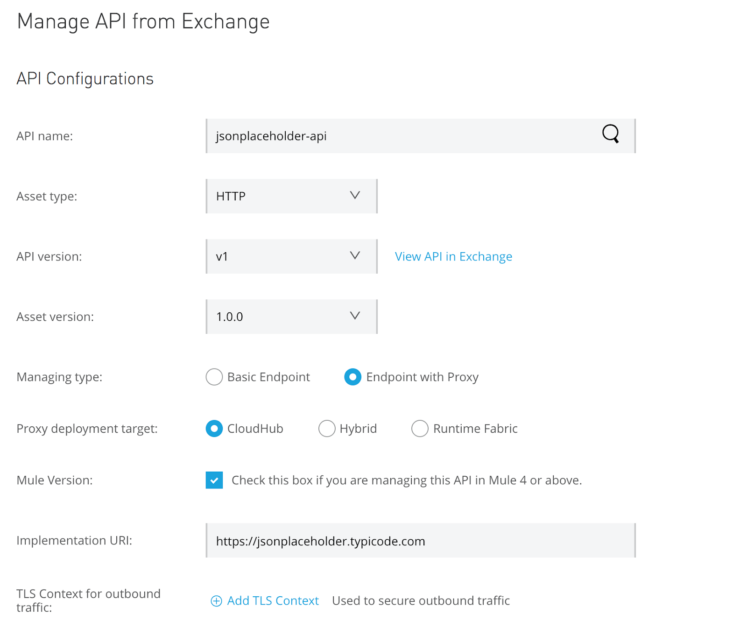

1. Select the secret group where you hosted your TLS Context from the Secret Group drop-down.
2. Select your TLS Context for your HTTPS API Proxy from the TLS Context drop-down.

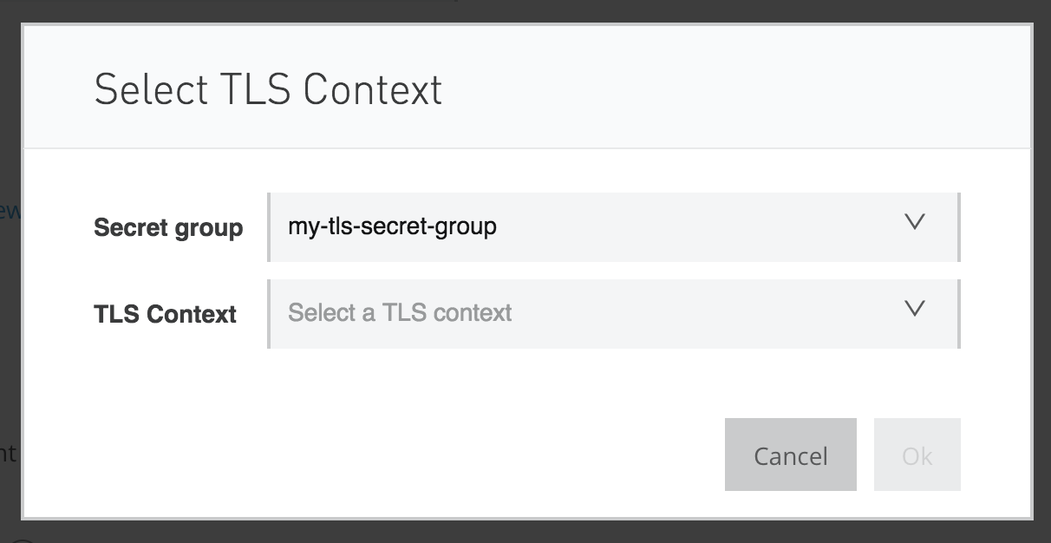
Additionally, if you want to enable SSL inbound traffic:
1. Click Advanced Options.
2. On the Scheme field, select HTTPS.
This makes the TLS Context for Inbound Traffic field appear.
3. Select Add TLS Context.
1. Select the secret group where you hosted your TLS Context from the Secret Group drop- down.
2. Select your TLS Context for your HTTPS API Proxy from the TLS Context drop-down.

4. Click Save.

Deploying the API Proxy

CloudHub

After you configured your API Proxy and selected CloudHub as the Proxy deployment target, your API Proxy will be automatically deployed, with the secrets already configured.

Your secrets are configured as secure property placeholders under the SecureProperties in your mule-artifact.json.
The amount of properties supplied depends on your selected configuration:

inbound.keystore.keyPassword_281324
inbound.keystore.password_281324

inbound.truststore.password_281324

outbound.keystore.keyPassword_281324
outbound.keystore.password_281324

outbound.truststore.password_281324
The 281324 suffix in this case is API Instance ID of your API Proxy.

If you inspect your API Proxy’s XML, you can see these properites being used in your trustore/keystore configurations:
<tls:trust-store path="outbound-truststore.jks" password="${outbound.truststore.password_281324}" type="JKS" insecure="true" />
Standalone

To deploy you API Proxy to a standalone server, you need to provide secured properties for each TLS Context.

1. Download the API Proxy.
1. In API Manager, select the version of the API proxy you want to download.
2. Click the Actions button in the top right side of your screen and select Download Proxy.
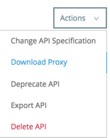

2. Take note of your API Instance ID under API Instance.

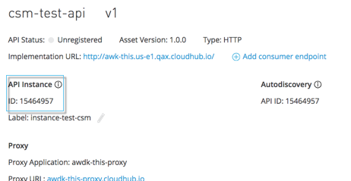

3. When running your standalone Mule instance, you need to provide the keystore and key passphrases as -D arguments, along with your API Proxy’s API Instance ID.
For example, if your API instance ID is 15464957, you need to pass the arguments:

./bin/mule \
-M-Dinbound.keystore.keyPassword_15464957=pass123 \
-M-Dinbound.keystore.password_15464957=pass123 \
-M-Dinbound.truststore.password_15464957=pass123 \
-M-Doutbound.keystore.keyPassword_15464957=pass123 \
-M-Doutbound.keystore.password_15464957=pass123 \
-M-Doutbound.truststore.password_15464957=pass123

Configuring your RAML/OAS API Proxy
1. In API Manager, navigate to Manage API to create your API Instance.
You can choose to either Creating an API instance by importing from Exchange or Creating an API instance by importing on API Manager.
2. In Asset Type, select RAML/OAS.
3. To configure your API Proxy for this API instance you need to select Endpoint with Proxy in the Managing Type fields.
1. Select your Proxy Deployment Target from the available deployment targets displayed.
2. Select the Check this box if you are managing this API in Mule 4 or above check mark.
3. Type in your Implementation URI.
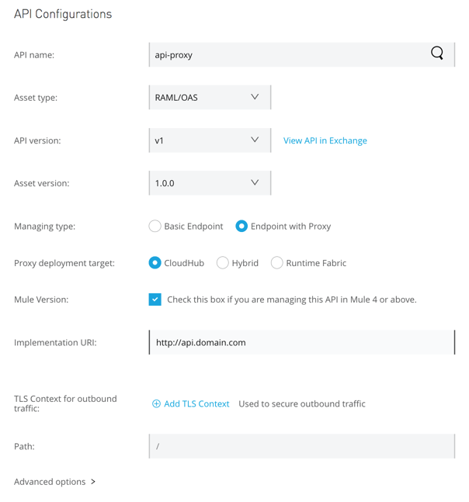

4. Click Advanced Options.

5. In Proxy Version, select latest.
This value ensures that your API proxy uses the latest released proxy version.

Versions 2.0.0 and later are the recommended version for OAS/RAML specs, since these versions add native OAS support.
If you upload an OAS API specification to an API proxy version 1.0 or earlier, your API specification will be translated to RAML.

6. Select your Scheme and Port number for your API proxy.
Optionally, you can set up an API Instance label and a Response Timeout.

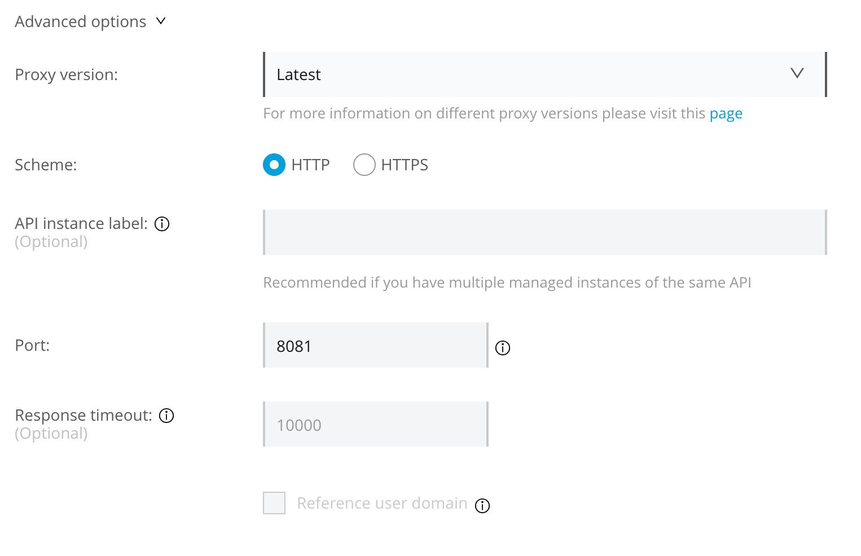
7. Click Save.

Deploying an API Proxy

A proxy is an application that provides a level of protection for your API. You don’t have to modify the API to guard against attacks on your web service. Mule Runtime hosts a Mule proxy application. There is a proxy type for each type of web service:

- RAML/OAS Proxy
- WSDL Proxy
- HTTP Proxy
- HTTPS Proxy

API Manager automatically generates the proxy app when you configure the API as an endpoint with a proxy and includes an Autodiscovery element in the app. Mule locks the API until all policies have been applied. The client app (consumer) calls the proxy which forwards the call to the API. After you deploy the app, Mule Runtime calls API Manager using the client ID and secret to get the policies for the API.

In most cases, the proxy you generate in API Manager is suitable for deployment. However, you can modify the proxy to log data to a file or send data to a Splunk account with the Anypoint Splunk Connector, for example.

You can import a proxy that you download from API Manager into Studio as a Mule Deployable Archive. You can then modify the proxy in Studio.

If you configured an endpoint with a proxy based on Mule 3 to use the HTTPS scheme, you need to modify a proxy to add HTTPS credentials following the Building an HTTPS Service instructions.
Additionally, if you configured a proxy based on Mule 4, you can build an HTTPS proxy using a TLS context stored in Anypoint Security’s secrets manager following the Building an HTTPS API Proxy instructions.

Now, you’re ready to deploy an auto-generated proxy.

Downloading an API Proxy

You use a proxy to manage your API without having to change its implementation and to prevent attacks on the server. Mule Runtime is the server that hosts a Mule proxy application.

Note: You must have View APIs Configuration permission to download a proxy.

You can download a proxy that you generated in API Manager by following this procedure.

- In Anypoint Platform, click API Manager.
- In API Administration, expand an API version to show its instances.
- Click the name of an instance of an API version.
- Select Download Proxy from the Actions dropdown.
The proxy downloads.

